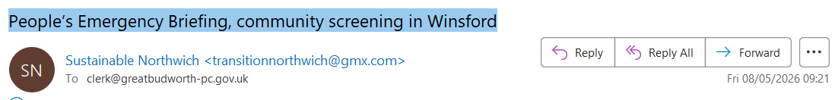
film about the threats to British life from ongoing damage to nature and to our climate. Full details below.
The film features footage from last November’s National Emergency Briefing, which brought together leading UK experts in climate science, food security, health, economics, national security and nature.
It presents a clear, measured overview of how the climate and nature crisis is affecting everyday life in Britain - and what the evidence says about risks and responses.
The initiative is explicitly non-partisan, and is supported by a wide range of organisations including National Trust, Church of England, Exeter University, the Royal Meteorological Society, WWF, National Education Union, and many more.
Local authorities play a vital role in responding to these challenges. Councils are central to reducing emissions across housing, transport, planning and infrastructure, and to strengthening local resilience in the face of increasing flood risk, heatwaves, food insecurity and wider systemic pressures.
They also hold important responsibilities in relation to emergency planning, local resilience forums and community risk assessment, making it especially important that elected members have access to the clearest possible scientific understanding of the risks ahead.
The purpose of the Briefing is to support informed democratic discussion and ensure that national and local decision-makers, alongside the public, share a common understanding of the scale and urgency of the challenge.
Following the 45-minute film, we will host a 45-minute discussion on what this means for our community, including implications for local preparedness, resilience and long-term planning.
We would greatly value your attendance - whether to listen and contribute, or simply observe the discussion. Your presence would signal the importance of open, evidence-based dialogue on an issue that affects residents across all wards and political affiliations.
If you are unable to attend, we would welcome a short written message to be read to attendees.
The event is free to attend and we are inviting health professionals, headteachers, governors, police, church leaders etc and local people. Please book tickets using the link below.
Thank you
Kind Regards
Anthony Powell on behalf of Winsford Sustainability Partners and Sustainable Northwich
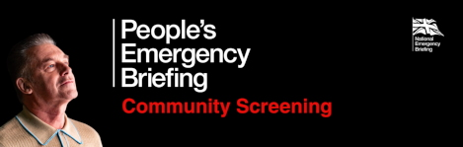
FREE FILM NIGHT: People's Emergency Briefing
Friday 15th May
Winsford Academy,
Grange Lane, Winsford, CW7 2BT
Film starts at 7.30pm. Doors open from 7pm
Film is 50 minutes
Conversation & Discussion afterwards
You are invited to a local screening of the People’s Emergency Briefing film, a film based on the recent National Emergency Briefing of MPs by leading experts.
Following the film, we will host a discussion about the impact of the film, implications for our community, and the change we wish to see.
We would greatly value your attendance. There are also many other screenings all over the country - please see this interactive map: https://www.nebriefing.org/screening-map
Over 16's only - those aged 16-18 need to be attending with a person over 18.

Book your free ticket here:
https://buytickets.at/winsfordsustainabilitypartners/2152124

Check out the trailer:
https://www.youtube.com/watch?v=JaI-dHgh65Q
https://transitionnorthwich.weebly.com/
Charity no.: 1186841

