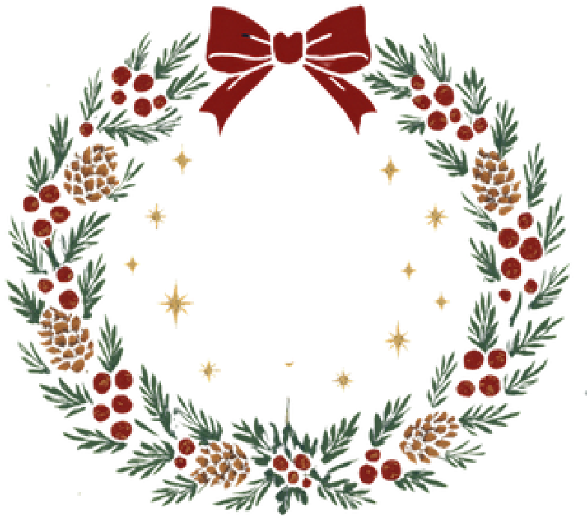
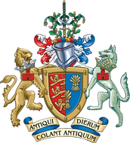



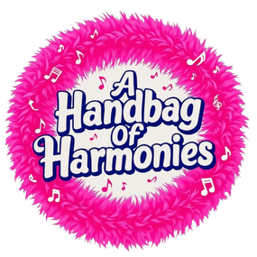

Here
The City of Chester Charter
Trustees
2
December
7.30
pm
£12
at Chester Town Hall
cordially invite you to a
Charit
y
‘Son
g
g
s from the Season’ Evenin
Featuring music from Rock Choir, Handbags of
Harmony, Proud Marys, and a young person’s
choir from Theatre in the Quarter
Tickets can be booked via Eventbrite
Tickets include an interval drink and a
mince pie. All proceeds go to Kidsbank Chester and the Lord Mayors
Charities.

