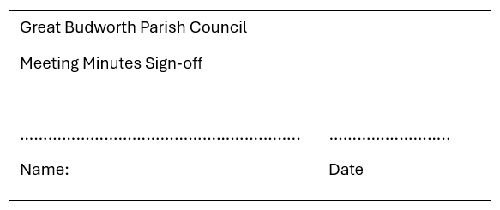
Minutes of Great Budworth Annual Meeting held on 12th May 2025

The meeting opened at 19:00

Present:
Parish Cllrs; Chair Dave Wilkinson (DW), Vice-Chair Cllr Justin Culver (JC), Cllr Steven Jennings (SJ), Cllr Steve Coppell (SC), Cllr Karen Williams (KW) and Cllr Tyler Hutton (TH)

Ward Cllrs: Lynn Gibbon (LG)

Clerk: Caroline Constable (CC)

Apologies:
Apologies received from Ward Cllrs Norman Wright (NW) and Phil Marshall (PM)

Chairman’s Report (in summary):

Chair Dave Wilkinson:

Thanks to previous chair Karen Hammond who stood down from the role as chair and as her position as a parish councillor to which we thank her for all she did.

After being elected as chair the last ten months have had a constant theme of items running throughout that time including:
- The Lower Pump house water supply with its above threshold levels for nitrate. Regular testing has now been put in place and levels have dropped below the threshold.
- The roof repair to the south side of the lower pump house is proving more trickier to complete with contractors becoming unattainable for getting the job done.
- Renewal of the tree survey which has flagged up one or two issues down The Avenue and will be looked at for this autumn/winter period to rectify.
- Sale of land with the coppice of Holme Oak trees behind the upper pump house to 50 Church Street which has generated a sum for the PC but also has removed the risk and responsibility of maintaining the trees from the Parish Council.
- This adversely brings me on to planning within the parish which has reminded us of the importance of keeping the conservation area and aesthetics of the village.
- The biggest thing the village has had to deal with is POTHOLES and even though the response time of council contractors to repair them from the time a resident report’s it has improved, there is only so long you can carry on patching up holes before serious consideration is needed for total resurfacing.

Finally, we welcomed Tyler on to the Parish Council who is settling into his role well.
Unfortunately, our long-standing councillor Malcolm Torrance decided to stand down and we thank him very much for his time and knowledge serving on the council.

I’d like to thank all my fellow councillors for all their work and input over the last twelve months and our clerk Caroline, who has dealt with all the backlog of policies and kept a firm control of finances and budgeting plus dealing with email issues.

Full report can be viewed on the website

Clerk’s Report (in summary):

In line with best practice guidelines issued by SLCC all policies and procedures including the Standing Orders have been moved onto a 4 year schedule for review. Policies will continue to be reviewed and updated if guidelines change.

Finances:
Precept £10462 April 2024 10% increase on previous year as agreed in December 2023, increase for 2025 of 10% also applied taking the Precept to £11508.
Bowling and Tennis clubs have both agreed to increase their rent to £5 each.
Parish Hall CIO have agreed to contribute to the cost of the Building’s insurance as initially agreed in 2021. £557 was deposited into the current account in March 2025. Further negotiations will be commenced in September when the next premium is Due.

Yearly accounts are as follows:
Starting balance in current account £26,267.15 (plus £2.18 in reserve account)
Yearly receipts £17,159.95
Staff costs £6840.27
Other costs £6873.75
From the current account starting balance £21,694.13 was moved into the Reserve account and then £20,000 of that was placed into a 95 Day Access account, interest earned on both accounts £618.33 (£111.84+£506.49)

Closing balance on current account £8,018.95
Closing balance on reserve account £1,808.15
Closing balance on 95 Day Access account £20,506.48

Full report can be viewed on the website

Election of Chair & Vice-Chair:
Clerk requested nominations for chair. SC nominated DW and JC seconded. DW was therefore re-elected as chair.
Clerk also asked for nominations for vice-chair. SJ nominated JC with DW seconding. DW re-elected as vice-chair.
DW & JC signed their Acceptance of Office forms.

Agreement of Standing Orders and Polices:
Clerk confirmed that as the Standing Orders and Policies have now move to the new schedule they will be reviewed in 2027 or earlier if guidelines change.

Agree Minutes of last meeting May 24:
Minutes agreed and signed

Any other Matters:
No further matters

Meeting closed at 19:11

