Cheshire West & Chester Council

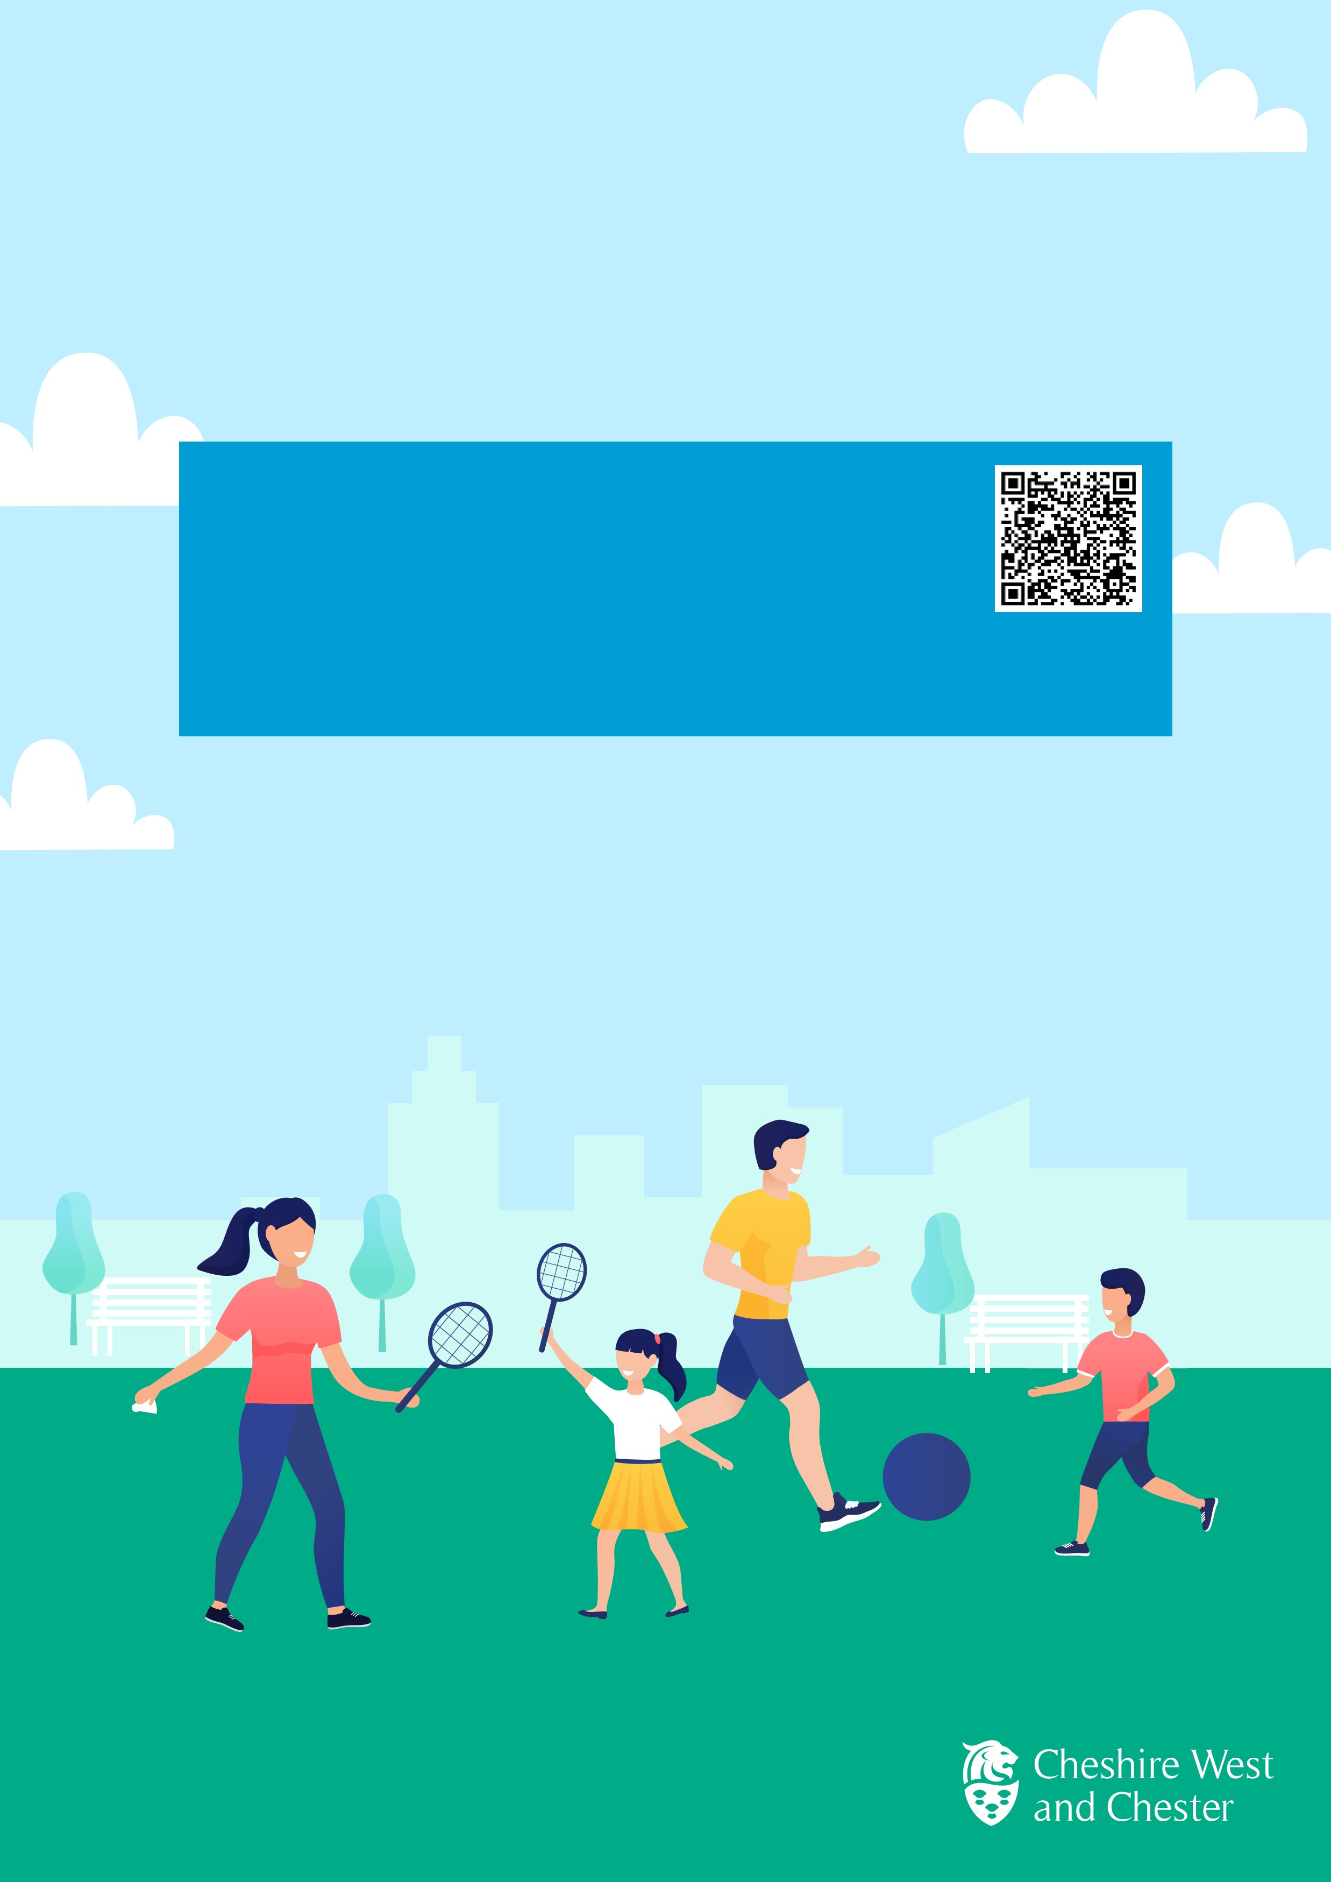School Holiday

# Activities

Take a look at all the fun things happening across Cheshire West and Chester over the holiday period.

Please use your smartphone to scan the QR code to access the School Holiday Activities page

Would you like to know what is on young people over the holiday period?

Find out more at [**https://www.cheshirewestandchester.gov.uk/news-andviews/campaigns/school-holiday-activities**](https://www.cheshirewestandchester.gov.uk/news-and-views/campaigns/school-holiday-activities)

Or search - ‘**Cheshire West and Chester, School Holiday Activities**’ to access all the information in one place.

*Information for activities and events have been provided by our partners. We may therefore not be aware of any last minute changes to their programme due to circumstances beyond their control. For further information please contact the event organ*