

**Cheshire West and Chester Borough Council**

**Road Traffic Regulation Act 1984**

**Temporary Prohibition of Traffic**

TRO18739 ST W Heath Lane **in** Marbury Ward

Notice is hereby given pursuant to the provisions of Section 14 of the Road Traffic Regulation Act 1984 that the Cheshire West and Chester Borough Council intend to make an Order the effect of which will be to temporarily prohibit/restrict traffic on the following length of road in Marbury Ward to enable Carriageway Surface Treatment Patching works to be carried out by Cheshire West And Chester Council.

Heath Lane: ROAD CLOSURE 08:00 - 17:00hrs Between the the junction with Belmont Road and Westage Lane

** Nothing in the Order shall prevent driving upon the said lengths of road of any vehicle which is being used for the conveyance of persons goods or merchandise to or from any premises situate on or adjacent to the lengths of road or in connection with agriculture building construction works of repair and the like or use in an emergency of vehicles for fire brigade ambulance or police purposes. A through route will not always be available and any vehicles not requiring access to properties on the length of road should use the alternative routes.

The Order will come into force on 14th April 2025 and will continue in force for a period not exceeding eighteen months or until the works which it is proposed to carry out have been completed whichever is the earlier. It is anticipated that the works will take approximately two weeks to complete. **Alternative routes for through traffic**

Traffic should proceed via

Belmont Road, Budworth Heath Lane, Budworth Road, Westage Lane

Highways Manager (Ref TRO 18739)

Transport and Highways Service, Highways Office, Guilden Sutton Lane, Guilden Sutton, Chester, Cheshire, CH3 7EX

Tel: 0300 123 7036

Email: highways@cheshirewestandchester.gov.uk

22nd January 2025

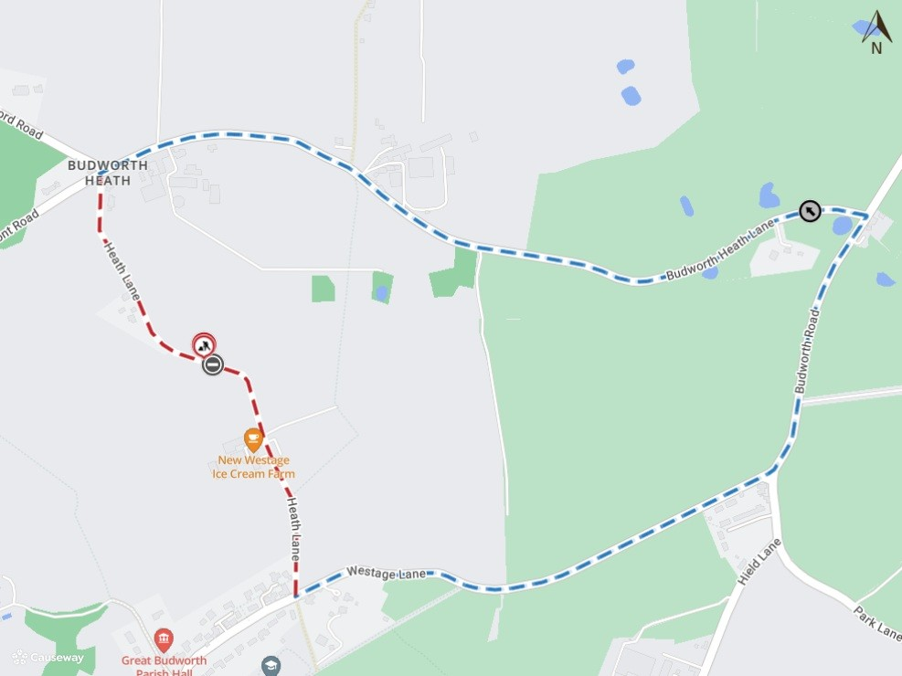

# Imagery © 2025 [MapTiler](https://www.maptiler.com/copyright/) | Imagery © 2025 [Hexagon](https://hexagon.com/legal) | © [MapTiler](https://www.maptiler.com/copyright/) © [OpenStreetMap contributors](https://www.openstreetmap.org/copyright)