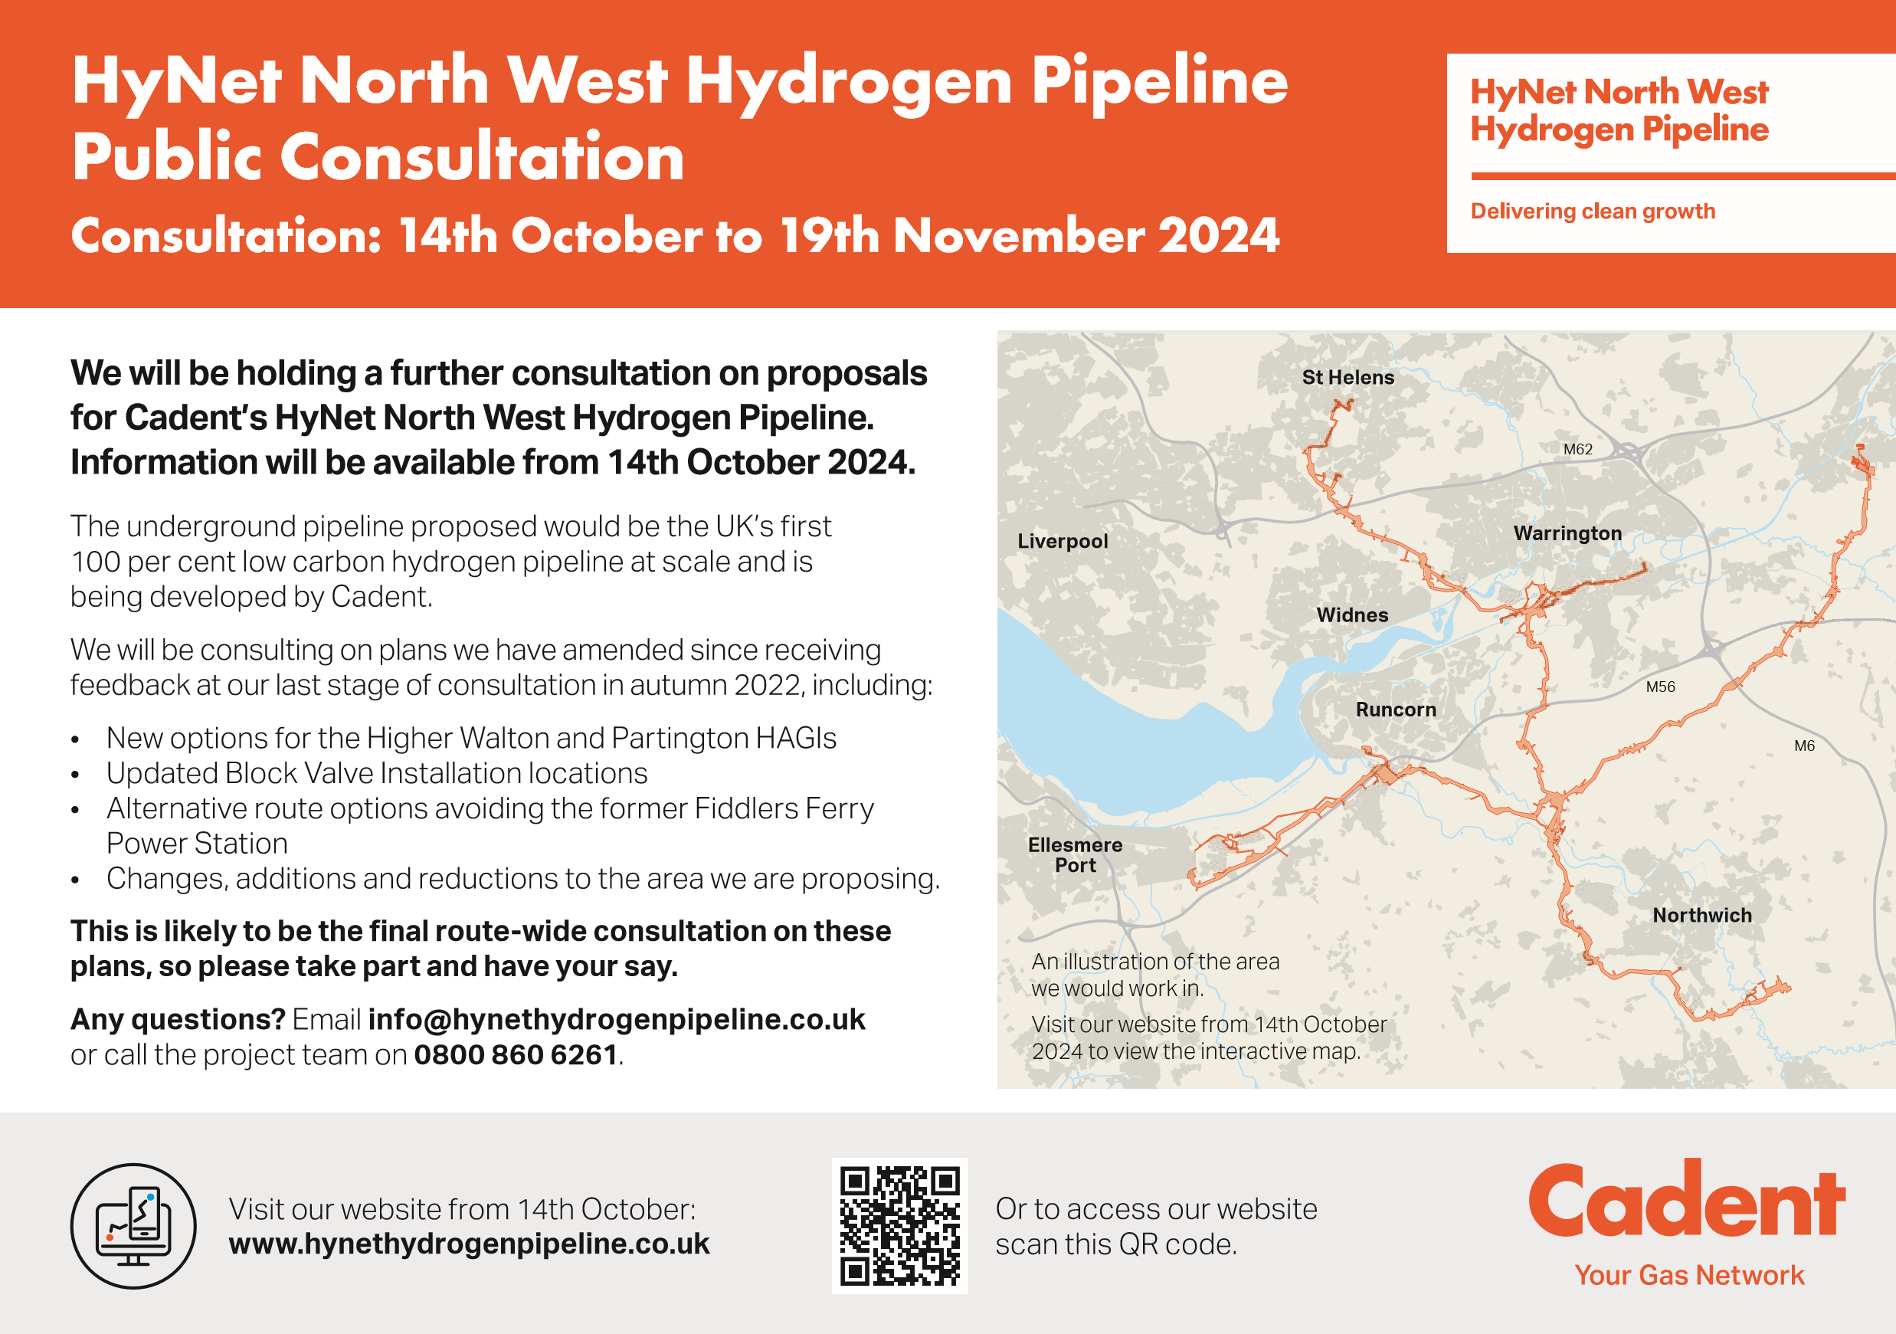

The consultation will run from

**14th October to 19th November 2024**.

You will be able to leave your feedback and access information about the consultation from 14th October 2024.

Email **info@hynethydrogenpipeline.co.uk**

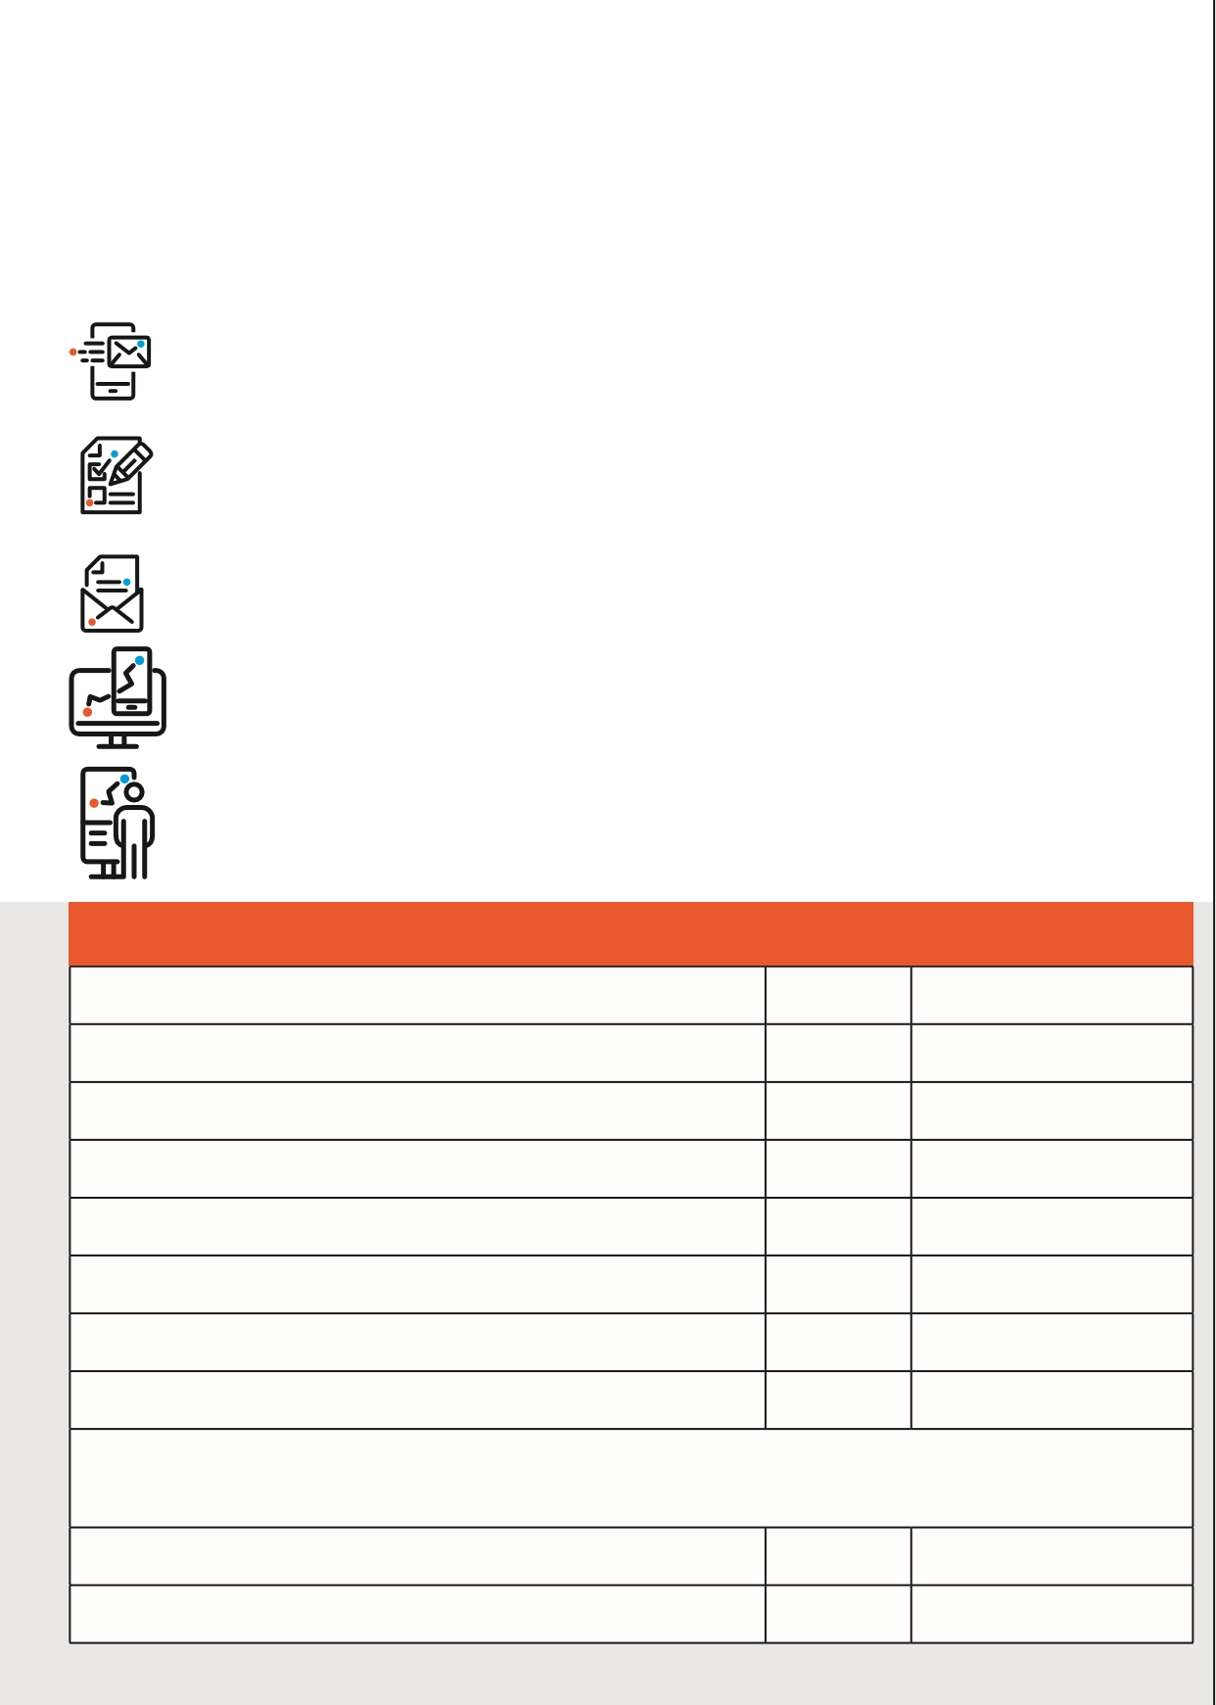Submit a feedback form, available from an in-person event, information point and online, or request one from our team on **0800 860 6261**.

Write to us at **FREEPOST HYNET NWHP**

View our interactive map .

Come to an event, where you can **speak with our team** and review consultation information.

**Consultation events**

**Whitley Village Hall, Higher Whitley** 16th Oct 4pm to 8pm

**High Legh Village Hall, Knutsford** 17th Oct 10am to 1pm

**Frodsham Community Centre, Frodsham** 17th Oct 5pm to 8pm

**Thatto Heath Library, St Helens** 18th Oct 12pm to 4pm **The Milner Church Institute, Moore** 19th Oct 10am to 3pm

**Westy Community Centre, Warrington** 21st Oct 3pm to 6pm

**Fuse ROC Centre, Partington** 23rd Oct 10am to 1pm

**Davenham Methodist Church Hall, Davenham** 24th Oct 5:30pm to 8:30pm

You can sign up for one of our two online events at

**www.hynethydrogenpipeline.co.uk/meet-our-team**

**Online event 1** 07th Nov 6pm to 7pm

**Online event 2** 12th Nov 6pm to 7pm