Cheshire West and Chester Borough Council
Road Traffic Regulation Act 1984
Temporary Road Closure
Westage Lane in Marbury Ward

Notice is hereby given pursuant to the provisions of Section 14 of the Road Traffic Regulation Act 1984 the effect of which will be to prohibit traffic on the following lengths of roads in Marbury Ward to enable Surfacing Remedial Works works to be carried out by Cheshire West And Chester Council

Westage Lane: ROAD CLOSURE 08:00 - 17:00 hrs 13th March 2024

Nothing in the Order shall prevent driving upon the said lengths of road of any vehicle which is being used for the conveyance of persons goods or merchandise to or from any premises situate on or adjacent to the lengths of road or in connection with agriculture building construction works of repair and the like or use in an emergency of vehicles for fire brigade ambulance or police purposes. A through route will not always be available and any vehicles not requiring access to properties on the length of road should use alternative routes.
The closure will come into force on 13th March and will be in force for a maximum of five days. It is anticipated that the work will last for approximately 1 day.

For diversion route, please see attached plan
Highways Manager (Ref TRO 16490)
Transport and Highways Service, Highways Office, Guilden Sutton Lane, Guilden Sutton, Chester, Cheshire, CH3 7EX
Tel: 0300 123 7036
Email: highways@cheshirewestandchester.gov.uk
8th March 2024
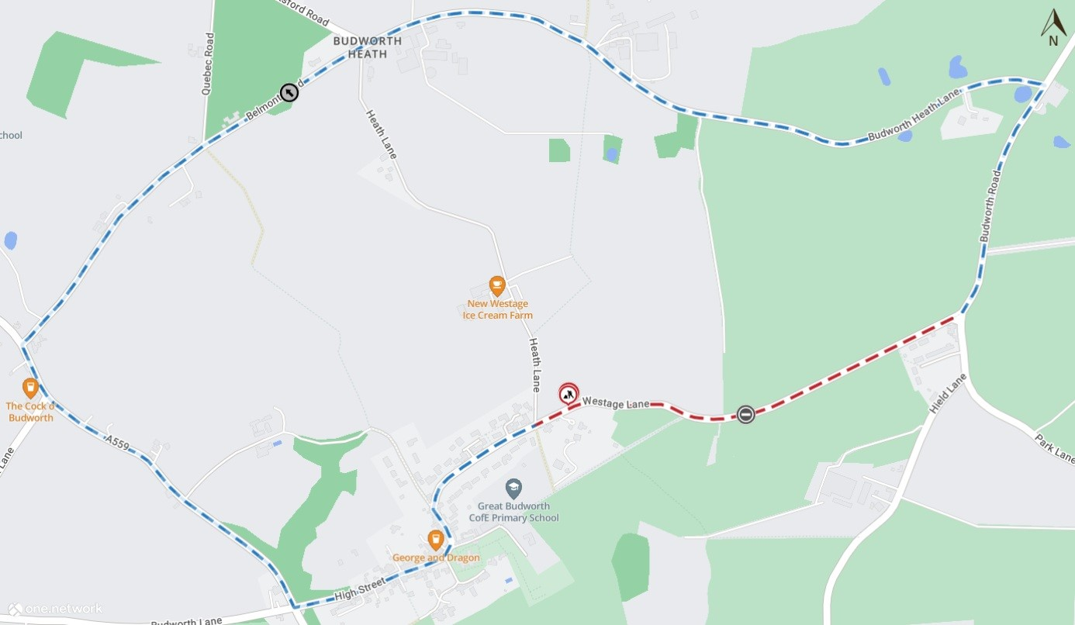
Map data © MapTiler © OpenStreetMap contributors

