GREAT BUDWORTH PARISH COUNCIL
Notes of the Meeting with the Highways Department, Cheshire West and Chester and Police Liaison, Cheshire Police - Monday 06 June 2016 – 08.30am
Present: Jamie Barron (JA), Area Engineer, Cheshire West and Chester Council; Chris Burnham (CB), Traffic Management Officer, Cheshire Police; Hilary Brudenell (HB), Chair, Great Budworth Parish Council; Malcolm Torrance (MT), Parish Councillor; and, Peter Mc Andrew (PMcA), Parish Councillor.
Issues Discussed:
- Review of action agreed at the last meeting:
  - Damage to properties at Ring O Bells corner by heavy wide vehicles. Update on action required to change the legal status of High Street, Church Street and Westage Lane to be width restricted and prohibit vehicles that exceed the weight limit.
Action Agreed: JB advised that Parish Council need to make a formal request through the CWAC Local Councillors for the change to be supported. HB agreed to request the support of Local Councillors.
  - Concerns about high vehicle speed in Westage Lane. Highways Department not yet undertaken any covert monitoring.
Action Agreed: JB agreed to arrange for the covert monitoring to take place sometime over the summer period but not when schools are on holiday as this may have an adverse effect on the outcomes.
- Draft parking warning letter for use with vehicles that are poorly parked or causing an obstruction.
Advice provided by the Highways Department and Cheshire Police: Don’t use yellow paper as it may be inflammatory to people receiving the notice. A preamble may be useful to explain that the notice is the result of a public consultation process. The last sentence to be amended to read “Failure to adhere to the above request may result in formal action for obstruction being considered.” The Police confirmed that it would be very difficult for any formal action to be taken by them.
- Parking issues in Great Budworth. To discuss the outcomes of the recent consultation and specific agreed action plans:
  - To discuss with Cheshire West and Chester Highways Department a design solution in keeping with the conservation area for signage regarding concealed access and egress in High Street.
Advice Given: To have ‘H Bars’ painted across these areas to restrict parking and to provide passing places to be available. Parish Council would have to pay for the work. The lines could be in primrose rather than yellow to be more sympathetic. Example provided below.

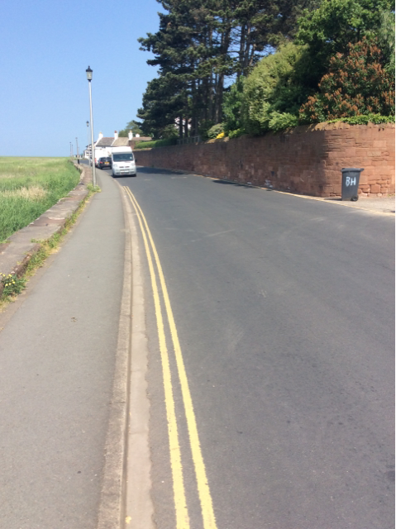

  - To explore further the introduction of formal restrictive parking arrangements (the detail of which to be defined at a later date) in the central area of the village in order to make it safer and to prevent the aesthetic features from being adversely affected by parked vehicles.
Advice Given: Difficult to achieve and enforce without a formal restricted parking arrangement. May consider using ‘No Parking’ notices on outside wall of Upper Pumphouse and on the Church wall.
  - To explore further the introduction of formal restrictive parking arrangements (the detail of which to be defined at a later date) on Church Street in order to make it safer.
Advice Given: Highways would not agree to a pavement due to costs. Consider a ‘public realm’ scheme. This would involve changing the environment to favour pedestrians through some street design. Suggested extended cobbled area on one side of the road (or could be some other type of block paving) and emphasising it as a pedestrian area. Suggest Parish Council contacts Neil Andrews, Stonemason, re; estimated costs. Would need to be to highway specification and require formal approval.

- The volume of cyclists travelling through the village in a dangerous manner and any action that could be taken.
Advice Given: Support writing to cycling clubs and national bodies to highlight issues. Cyclists are mainly on unofficial ‘rides’ and therefore difficult to regulate. Difficult to take action as not considered to be a significant problem.

Peter S McAndrew – 06/06/2016

