GREAT BUDWORTH PARISH COUNCIL MEMBERS 2016-17

Councillor Hilary Brudenell (awaiting image)
Chairman
Parish Council Committee Membership:
Planning Committee
Finance Committee (Chairman)
Staffing Committee (Chairman)
Risk Assessment Committee

Local Organisation Representative:
Parish Hall

Contact Information:

Telephone: 01606 892404
Email: hilarykeithbrudenell@btinternet.com

Councillor Robert Collier
Vice Chairman

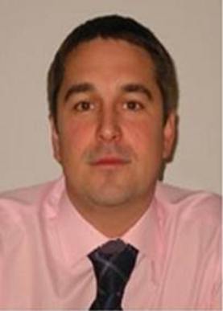
“I have lived in Great Budworth with my family for over 10 years. We enjoy life in the village, we have good friends and neighbours and appreciate the strong sense of community.

I am a chartered surveyor with over 20 years experience in the construction and property sector, currently working as the head of property services involved with regeneration and community issues.

I welcome the appointment to the council and the opportunity to build on the previous council achievements with regard maintaining and improving the village and the community facilities.”

Parish Council Committee Membership:
Planning Committee
Finance Committee
Staffing Committee
Risk Assessment Committee (Chairman)

Local Organisation Representative:
Parish Hall

Contact Information:

Telephone: 01606 891454
Email: bobcol_98@yahoo.com
Councillor Lesley Hopkinson

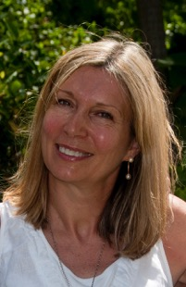
“I have now lived in Great Budworth for over ten years and a large part of that has been spent renovating and restoring our house. Nick and I moved here because we loved the idea of living in a village community in such a beautiful setting - and we owed it to the village to do the best job we could on The Old Hall - although it has been a far bigger project than we envisaged!
Along with a love of the village and local countryside, I enjoy living in a place where we know and care about our neighbours - and feel we really need to maintain and build on these community foundations. There are some wonderful social activities here run by some local heroes - and everyone is welcome.
Originally a secondary school teacher myself, I now represent the Parish Council on the Governing Body here at Great Budworth School - and am enjoying this return to education at the primary level.”

Parish Council Committee Membership:
Planning Committee
Finance Committee
Staffing Committee
Risk Assessment Committee

Local Organisation Representative:
Parish Hall

Contact Information:

Telephone: 01606 891391
Email: lesley@hoppyhome.co.uk

Councillor Peter McAndrew

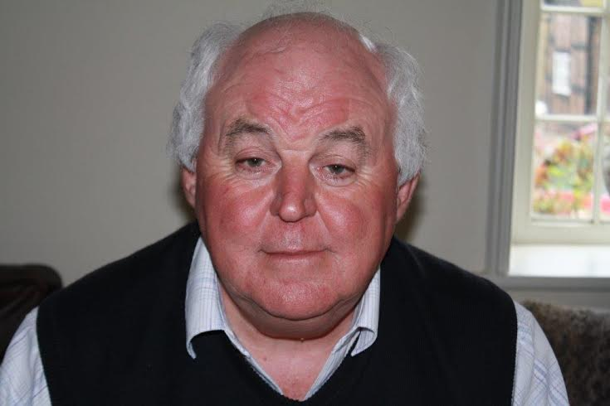

Parish Council Committee Membership:
Planning Committee
Finance Committee
Staffing Committee
Risk Assessment Committee

Local Organisation Representative:
Tennis Club
Cricket Club

Contact Information:

Telephone: 01606 891213
Email: psmcandrew@btinternet.com

Councillor Marie Kershaw

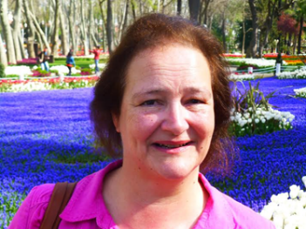
“I consider it a great privilege to have been elected to Great Budworth Parish Council. I look forward to being part of a very distinguished team and making a contribution to life in a very special Cheshire village.
I have lived in Great Budworth for 11 years, moving from nearby Over Tabley. I am married to Richard and we have four grown up children. I have achieved a long term ambition this year and become a member of the Great Budworth Garden Club. I enjoy cooking and gardening and I support our eldest son who is an extreme tri athlete.”

Parish Council Committee Membership:
Planning Committee
Finance Committee
Staffing Committee
Risk Assessment Committee

Contact Information:

Telephone: 07870 675342
Email: mariedkershaw@hotmail.com

Councillor Hazel Forwood

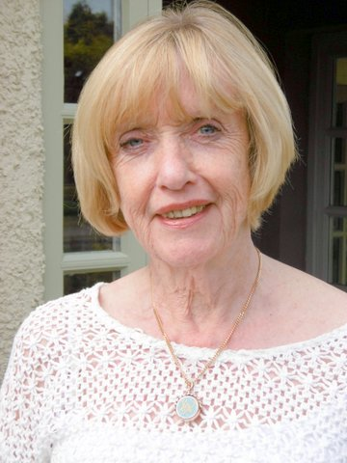
“Having lived in and around Great Budworth for over 30 years, and have in that time always had a great interest in the affairs of the village, and the need to protect its special qualities. I am a member of the Heritage society, and wish to help to keep the villagers unspoilt as it is.
I now consider it a great privilege having been voted to serve on the Parish Council, and to be given the opportunity to work for the benefit of the Parish, and to help in any way I can, to seriously consider the views of the residents, and any issues of concern to the community.”

Parish Council Committee Membership:
Planning Committee
Finance Committee
Staffing Committee
Risk Assessment Committee

Local Organisation Representative:
Parish Hall
Heritage Society

Contact Information:

Telephone: 01606 891908
Email: hazelforwood2@gmail.com

Councillor Anna Lee

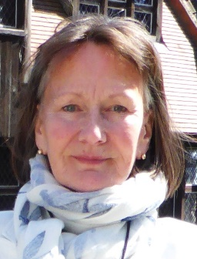 “I've been involved in village life since moving to Great Budworth upon retiring as a university lecturer in 2007. As a parish councillor and as Hon. Secretary of the Heritage Society, my main interest has been the impact on the parish of the modern planning regime. I'm grateful to have been re-elected to the Parish Council and look forward to doing more to maintain both the beauty of the village and the good spirit of the community.”

Parish Council Committee Membership:
Planning Committee
Finance Committee
Staffing Committee
Risk Assessment Committee

Local Organisation Representative:
Heritage Society

Contact Information:

Telephone: 01606 892352
Email: annalee1@btinternet.com

Councillor Malcolm Torrance (awaiting image)

Parish Council Committee Membership:
Planning Committee
Finance Committee
Staffing Committee
Risk Assessment Committee

Local Organisation Representative:
Heritage Society
Parish Hall
Bowling Club

Contact Information:

Telephone: 07606 892295
Email: malcbudworth@gmail.com

