LOCAL GOVERNMENT ACT 1972

NOTICE OF ANNUAL PARISH MEETING
FOR GREAT BUDWORTH

NOTICE IS HEREBY GIVEN THAT-

The Annual Assembly of the Parish Meeting for Great Budworth Parish Council will be held at Great Budworth Parish Hall on 11th May 2015 at 8.30pm

The business to be transacted at the Meeting will be as follows:-

- Welcome and record attendance

- Apologies

- Declarations of Interest with regard to items on the agenda

- Minutes of the previous Annual Parish Meeting held on 12 May 2014 were agreed at the Ordinary Parish Council Meeting in July 2014

- Chairman’s Report for 2014/2015
Clerk’s Report for 2014/2015

- Public Forum

- Dates of future meetings

Signed

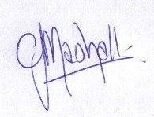

Caroline Marshall

Clerk and Responsible Financial Officer to Great Budworth Parish Council

5th May 2015

